Machine Café & Deli
1024 Market St, San Francisco, CA 94103
machinedeli.com

Closes at 3 pm.

Java bar pouring high-end brews & serving build-your-own sandwiches stuffed with handcrafted meats.

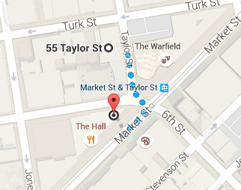

Dottie’s True Blue Café
28 6th St, San Francisco, CA 94103
dottiestruebluesf.com

Closes at 4 pm.

Big helpings of American morning fare & lunch items on tables covered with old movie-star photos.
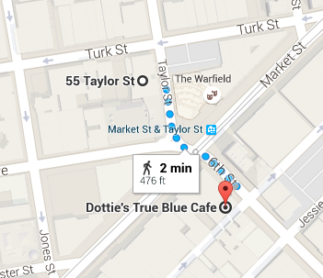
Blue Bottle Coffee
66 Mint St, San Francisco, CA 94103
bluebottlecoffee.com

Closes at 7 pm.

Trendy cafe chain offering upscale coffee drinks & pastries, plus beans & brewing equipment.

Show Dogs
1020 Market St, San Francisco, CA 94102
showdogssf.com

Closes at 9 pm.

Upscale fast-food spot serving organic hot dogs with homemade condiments, sandwiches & beer.

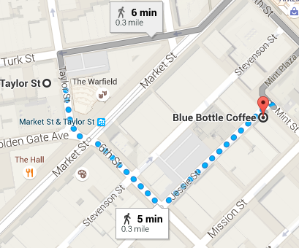

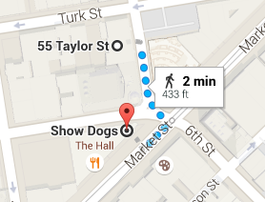

Westfield Shopping Centre
Foodcourts
https://www.westfield.com/sanfrancisco

Closes at 8:30 pm

9-story mall featuring over 170 shops & restaurants, a multiplex & a dome-covered atrium.

The Market
1355 Market St, San Francisco, CA 94103
visitthemarket.com

Closes at 9 pm.

Food emporium with cafes & counter-serve eats, plus groceries in a vast, industrial-chic space.

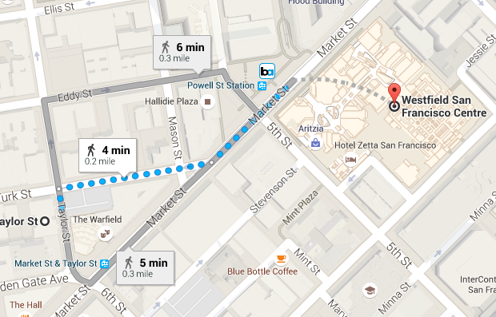

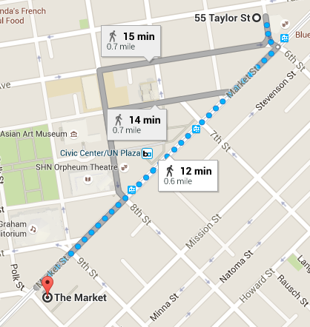
The Grove
690 Mission St, San Francisco, CA 94105
thegrovesf.com

Closes at 11 pm.

Popular spot for American home cooking in a mountain-lodge-like setting with communal seats.

Mikkeler Bar
34 Mason St, San Francisco, CA 94102
mikkellerbar.com

Closes at 2 am.

A famed brewer's industrial-cool bar offers rare tap & bottled beers alongside upscale pub grub.
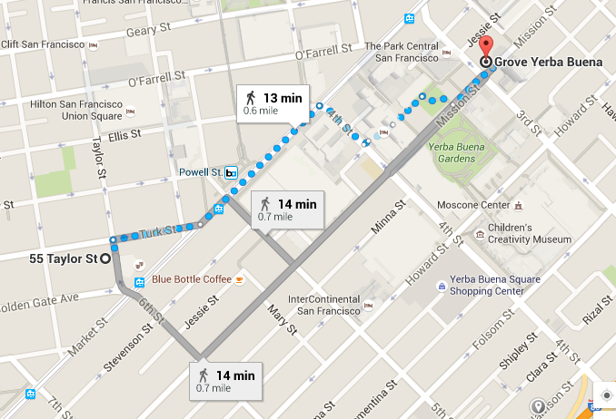

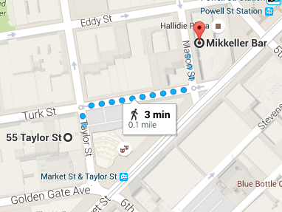
The House of Shields
39 New Montgomery St, San Francisco
thehouseofshields.com

Closes at 2 am.

Restored old-school bar that's an after-work standard for high-end, handcrafted cocktails.

Louie’s Bar
55 Stevenson St, San Francisco, CA 94105
pourguysinc.com

Closes at 2 am.

Pub grub & draft beer are on tap at this low-key, brick-walled hangout serving food late at night.
